`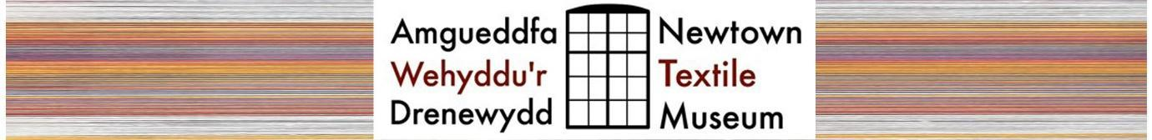

Information on tours in 2024
Group tours of the Museum can be arranged and are usually organised for the times when the Museum is closed to the public. (All day Monday and Wednesday; up to 12 noon on Tuesday, Thursday, Friday and Saturday; and early evenings during the week). If the tour is in the morning on a day when the Museum is open to visitors, those on the tour can stay on to spend more time in the Museum, as a visitor, if they like.

Groups of up to 15 people at one time are the norm. But we can accommodate larger groups, including bespoke coach tours, by special arrangement. Any children under 16, as part of a group, must be accompanied by a responsible adult.

Tours usually last at least an hour and involve an introductory talk and time to explore the building and the exhibits. During the daytime, it is possible to add a demonstration of spinning or weaving to the visit. This usually runs alongside, and overlapping with, the tour. An hour and a half should be allowed for a tour plus demonstration. There is a charge for both types of guided tours.

For groups of 10 or less these are:
- Introductory talk and tour of the building £30
- Introductory talk and tour of the building, plus a demonstration £75
For groups of 11-15 people:
- Introductory talk and tour of the building £45
- Introductory talk and tour of the building, plus a demonstration £90
For groups of over 15 people, £3 a head is charged for each additional person.

Tours can be customised to suit your interests but will generally be a mix of social and industrial history showing the development of the weaving industry within the town. If you would like a tour in Welsh, please ask. We will try to accommodate your request.

We can also offer a talk at your venue for the cost £45 plus modest travel costs.

If you would like to arrange a tour please email admin@newtowntextilemuseum.co.uk with suggested times, dates and particular interests.

Please note that there is no lift in this 1830s building. Those attending will benefit most if they are able to walk upstairs. In some areas (loom floors) there are also uneven floors. Some information is available on the ground floor.

Parking
- Daytime parking outside the Museum is limited to 1hr. Ample parking in the main town car park (in Back Lane) just a short walk across the Long Bridge.
- There are no parking restrictions in the adjoining streets but a very limited numbers of spaces.
- There are some coach parking spaces in the Back Lane car park.

Refreshments are not available in the Museum itself. There are a variety of cafes and pubs nearby in town centre.

Museum opening hours

Every Tuesday, Thursday, Friday and Saturday, from 12 – 4pm (suggested last entry 3.30) between May 2 and September 30 2024.

January 2024

