Evan Clayton and his descendants

I. Evan¹ Clayton was born on 9 Feb 1755 at Port House, Llanllwchaiarn, Newtown. He married Ann Humphries on 4 May 1779. He was paid for 4 days at 15d for repairing the weir in Caersws in 1793. He died on 16 Feb 1820 at Port House, Llanllwchaiarn, aged 65; and was buried on that day.

A. Mary Clayton, baptised on 20 February 1780 Llanllwchaiarn Parish Baptism register.

B. Evan² Clayton was born before 19 Aug 1780 at Llanllwchaiarn, Newtown. He was baptized on 19 Sep 1780 at Llanllwchaiarn Parish Church.

C. Ann² Clayton was born before 4 Jan 1784 at Llanllwchaiarn, Newtown. She was baptized on 4 Jan 1784 at Llanllwchaiarn Parish Church, Newtown. She died before 26 May 1792.

D. Jane² Clayton was born before 21 Feb 1788 at Llanllwchaiarn, Newtown. She was baptized on 21 Feb 1788 at Llanllwchaiarn Parish Church, Newtown.

E. Thomas² Clayton was born on 7 Nov 1790 at Llanllwchaiarn. He married Mary Humphreys on 11 Jun 1820 at Newtown, Montgomeryshire. (Mary died on 4 March 1877, Chapel St, Penygloddfa, Llanllwchaiarn. Buried in Llanllwchaiarn Parish Cemetery). He was a flannel weaver in 1841. As of Apr 1841, Thomas Clayton lived at South St, Llanllwchaiarn, Newtown, Montgomeryshire. As of 1851, Thomas Clayton lived at Upper Bridge Street, Newtown, Montgomeryshire. He died 27 January 1859 at Frankwell, Llanllwchaiarn.

1. Ann³ Jones. Nee Clayton She was born before 7 Aug 1820. She was baptized on 7 Aug 1820 at Wesley Methodist Church, Newtown, Montgomeryshire, Wales. She married Thomas Jones on 14 Jul 1846 at Llanllwchaiarn Parish Church, Newtown, Montgomeryshire. She was a hotel servant in Apr 1881. She was a laundress in Apr 1891 at No 32 Crescent Street, Newtown. As of Apr 1901, Ann Clayton lived at Main Street, Caersws, Montgomeryshire; living with daughter Annie Lewis and husband John Lewis. Died 8 August 1906. Husband Thomas died 10 November 1896. Buried in same grave in Llanllwchaiarn Parish Cemetery.

- Thomas⁴ Jones was born on 30 July 1846 at Commercial Street, Llanllwchaiarn, Newtown, Montgomeryshire. As of Apr 1851, Thomas Jones lived at Crescent St, Newtown, Montgomeryshire; at the home of his grandparents, Thomas and Mary Clayton. He was listed as living with his parents Thomas and Ann Jones and with his grandmother Mary Clayton and Uncle Thomas Clayton in the 1861 Census. The Claytons were in Crescent Street and the Jones’ in the Yard off Crescent Street so he probably moved between the two households. He married Ellen Maria Merrick in Welshpool in 1868. They and their three year old son Julian Pevril Jones emigrated to Hawkes Bay New Zealand in 1874. Source Margaret Jones, wife of Fred, who is Thomas’ great grandson)

b) William⁴ Jones was born in 1849 at Commercial Street, Llanllwchaiarn, Newtown, Montgomeryshire.

c) Ellen⁴ Jones was born on 8 June 1851 at Crescent Street, Penygloddfa, Newtown, Montgomeryshire. She was a laundress. living with her parents in Crescent Court in Apr 1871. She married William Manuel in Oct 1872 at Newtown, Montgomeryshire. She and William emigrated to Brisbane, Australia in 1883, arriving on the ship Jerusalem.

d) William⁴ Jones was born in 1854 at Yard off Crescent Street, Newtown, Montgomeryshire. He was an apprentice wool sorter in Apr 1871 at Crescent Court, Newtown, Montgomeryshire.

e) Mary⁴ Jones was born in 1857 at Yard off Crescent Street, Newtown, Montgomeryshire.

f) Annie⁴ Jones was born in 1860 at Yard off Crescent Street, Newtown, Montgomeryshire. She was a scholar. Living with her parents in Apr 1871 at Crescent Court, Hendidley, Newtown, Montgomeryshire. She was a woollen weaver in Apr 1881 at Crescent Street, Newtown, Montgomeryshire. She married John Lewis on 9 May 1881 at Parish Church, Llanllwchaiarn, Montgomeryshire. As of Apr 1901, Annie Jones lived at Main Street, Caersws, Montgomeryshire. John Lewis was a master saddler. He and Annie emigrated to Queensland in 1911 with four of their children on ‘Orsova’. They lived in Red Hill, Brisbane in a house named Brynhyfryd. A photograph is attached below. The children that accompanied them were Marvis Hilda, George Norman, Arnold Gordon and Osborne Llewellyn.

(1) Margaret Annie⁵ Lewis was born on 13 August 1881 at Crescent Street, Newtown, Montgomeryshire. She was married Charles Dobbie in Liverpool in 1903. In 1914 she emigrated to Queensland with her three sons on the ‘Osterley’.

(2) John Richard⁵ Lewis was born in 1885 at Caersws, Montgomeryshire. He was a carpenter. Living with his parents in Apr 1901 at Main St, Caersws, Montgomeryshire. In 1911 he was living in Treforest, Glamorganshire with his wife and children and brother George Norman Lewis. He was a labourer at a coal mine. In 1920 John and his family emigrated to Queensland on the ‘Ormonde’ to join the rest of his family.

(3) William Ewart⁵ Lewis was born in 1887 at Caersws, Montgomeryshire. He was a saddler, working with his father and living with his parents. in Apr 1901 at Main St, Caersws. He emigrated to Queensland, Australia, probably in 1909 on ‘Orvieto’.

(4) Marvis Hilda⁵ Lewis was born in 1893 at Caersws, Montgomeryshire. In 1911 she was working as a nursemaid in London.

(5) George Norman⁵ Lewis was born in 1895 at Caersws, Montgomeryshire. In 1911 he was living with his brother John Richard Lewis and family in Treforest, Glamorganshire. He was a hewer at a coal mine.

(6) Arnold Gordon⁵ Lewis was born on 9 July 1898 at Caersws, Montgomeryshire.

(7) Osborne Llewelyn⁵ Lewis was born on 8 August 1899 at Caersws, Montgomeryshire.

g) Margaret⁴ Jones was born in 1863 at Penygloddfa, Newtown, Montgomeryshire. She was a scholar. Living with her parents in Apr 1871 at Crescent Court, Hendidley, Newtown, Montgomeryshire. She was a woollen weaver. Living with parents in Apr 1881 at Crescent Street, Newtown, Montgomeryshire. She emigrated to Queensland in 1885 with her husband Daniel Jones on ‘Chyebassa’.

2. Thomas³ Clayton was born on 15 Dec 1821 at Newtown. He was baptized on 19 Sep 1827 at Wesley Methodist church, Newtown. He was a Woollen spinner in 1851. He was a woollen spinner in Apr 1861. As of Apr 1861, Thomas Clayton lived at Crescent Street, Newtown, Montgomeryshire; Living with his mother Mary and nephew, Thomas Jones. As of 1871, Thomas Clayton lived at Crescent Street, Newtown, Montgomeryshire. His mother Mary was still living with him. He was a woollen spinner in Apr 1871.

3. Eleanor³ Clayton was born on 30 Nov 1823 at Llanllwchaiarn, Newtown. She was baptized on 19 Sep 1827 at Wesley Methodist Church, Newtown.

4. Mary³ Clayton was baptized on 19 Aug 1827 at Wesley Methodist Church, Newtown. She was born on 1 Sep 1827 at Llanllwchaiarn, Montgomeryshire.

5. William³ Clayton was born on 7 Mar 1834 at Welshpool, Montgomeryshire. He married Mary Ann Morris in April 1860. (Mary Ann Morris was the daughter of Isaac Astley and Elizabeth Morris – probably born before their marriage but she appears in the 1851 census as Mary Astley). In 1861 he was living with his sister Ann Jones nee Clayton in The Yard, Crescent Street, while his wife Mary was recorded as living with her parents. He was a shoemaker in Apr 1871 at Jones Court, Newtown, Montgomeryshire.

a) William⁴ Herbert Clayton (Morris) married Mary Joseph Meenaghan at Llanllwchaiarn Parish Church on 28 October 1879.

b) Ann Elizabeth⁴ Clayton was born in 1862 at Newtown. She married Michael Meenaghan (brother of Mary Joseph Meenaghan) at Llanllwchaiarn Parish Church on 12 July 1879. In the 1881 census they were living in Silverdale, Staffordshire, together with her brother William and Mary Clayton and their son, also called William.

c) Arthur⁴ Clayton was born in 1864 at Newtown.

d) Mary Emelia⁴ Clayton was born in 1868 at Newtown.

e) Eleanor Eda⁴ Clayton was born in 1871 at Newtown.

6. Amelia³ Clayton was born on 19 Oct 1836 at Llanllwchaiarn, Montgomeryshire. She was baptized on 14 Nov 1836 at Wesley Methodist Church, Newtown. She was an apprentice dress maker in 1851.

E. James² Clayton was born before 24 May 1793 at Llanllwchaiarn, Newtown. He was baptized on 24 May 1793 at Llanllwchaiarn Parish Church, Newtown.

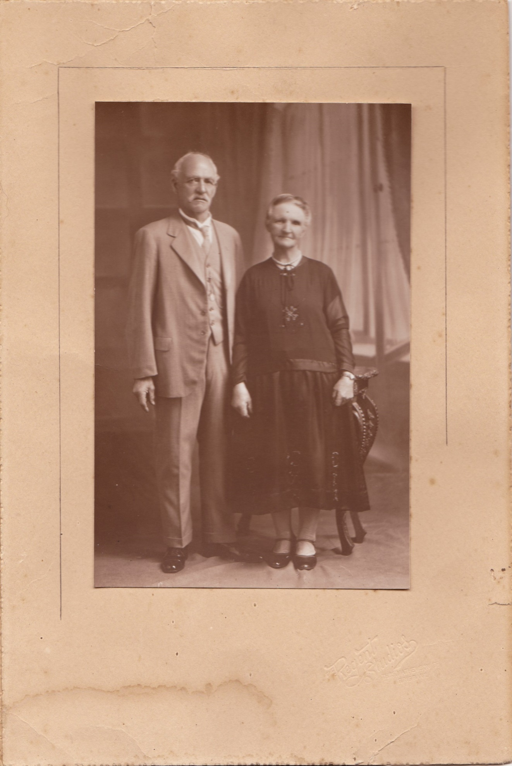
John and Annie Lewis from Newtown. March 1931, Brisbane.

Notes:
- Cleaton and Clayton – the surnames seem to have been interchangeable and was often decided by the record’s scribe.
- There seems to be some uncertainty relating to Thomas Clayton and his parents. Some records indicate he was born in 1790 in Llanllwchaiarn to Evan Clayton and his wife Ann, but others suggest his parents were John and Eleanor Clayton and he was baptised in Bettws Cedewain in 1796. 1851 Census records show his place of birth as Llanllwchaiarn.
- William Clayton and his family emigrated to Connecticut USA in 1891

